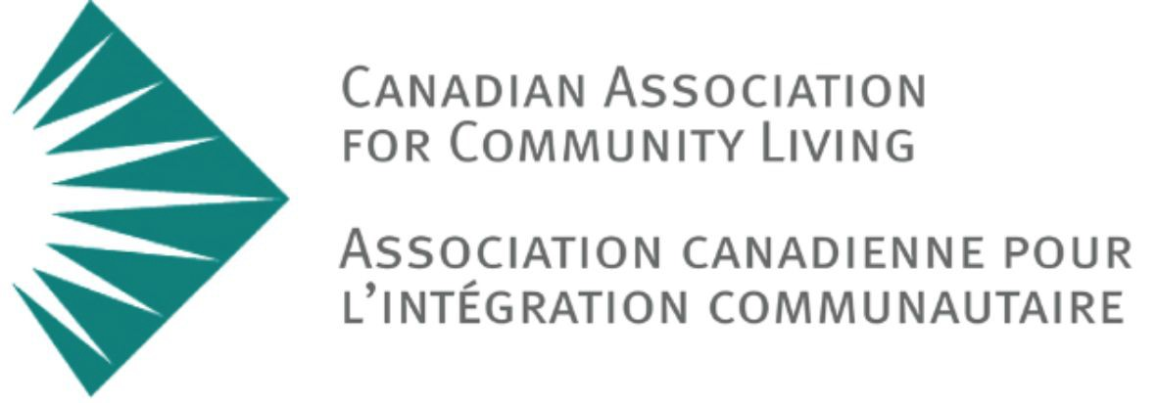

present

Flourishing: a documentary

CALL FOR PARTICIPANTS

Flourishing is a short documentary about suffering and human flourishing.

The laws and normative practice surrounding Medical Assistance in Dying in Canada are in flux. As judges, legislators and policymakers interpret the details of the Supreme Court’s Carter Decision and Parliament’s subsequent Bill C-14, Canadians must consider fundamental philosophical questions such as “what makes a life worth living?” and “what is a good life?”.

The Canadian Association for Community Living wishes to expand Canadians’ understanding of these questions in a documentary that profiles the lives of three individuals who have experienced considerable suffering due to mental health, physical disability, or cognitive and intellectual disability. The goal of this film is to show how flourishing is complex and often
co-exists with suffering in surprising ways.

Our ideal characters face circumstances that truly constitute suffering, yet in each case still find ways to flourish, or lead a life worth living. While we hope this character is compelling for audiences, we are deliberately not trying to tell a story of a person who has overcome adversity. Rather than a story of how a few exceptional individuals have overcome suffering, we seek to show how those facing adversity juggle both suffering and flourishing simultaneously.

Details:
- Shooting will last 3-4 days during July, August and September 2018
- Participants will have final say about what is included in film

If you have questions, know a candidate, or wish to learn more about participation, contact scott@adjacentpossibilities.org. Timeline is imminent, please distribute in your networks.

With thanks, Scott Baker
Producer, Flourishing

