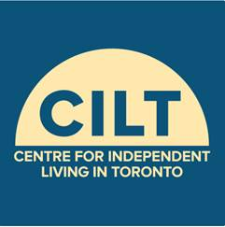 Centre for Independent Living in Toronto

Presents a Free Workshop on

Ontario Disability Support Program (ODSP) and Next Self-Advocacy Steps

- Want to know more about recent changes to ODSP/Ontario Works (OW) and what it means?
- Want to know more about what advocacy steps you can do as an individual on ODSP/OW?

Date: Thursday May 9, 2019

Registration: 1:00pm-1:30pm

Workshop: 1:30pm-4:00pm

Place: CILT Board Room, Suite 902, 365 Bloor St East
(At Sherbourne St)

Guest Speakers:
- Andrea Hatala, Co-Chair - ODSP Action Coalition
- Guest Speaker TBA - Income Security Advocacy Centre (ISAC)

This FREE event is wheelchair accessible and promotes a scent-free environment. Attendant services and light refreshments
provided. TTC Tokens, other accessibility accommodations and/or dietary needs will be made available upon reasonable advance request.

RSVP by Thursday May 2, 2019. Seating is limited to 20.
Register by Eventbrite: https://odspnextsteps.eventbrite.ca
Or contact Robin at inquiry@cilt.ca or 416-599-2458 ext. 293
Funding support provided by United Way Greater Toronto, City of Toronto, Toronto Central Local Health Integration Network (LHIN), and Independent Living Canada

