Wills and Estate Planning for Adults with Disabilities
with Elisa Mangina from PooranLaw

Please join us for a workshop that will address the questions:
What is a will? Why should I make a will?
How do I make a will? What happens if I don’t have a will?

WHEN: Wednesday Dec 11, 2019
Registration: 1pm
Workshop: 1:30-3:30pm
WHERE: Centre for Independent Living in Toronto
365 Bloor Street East, Suite 902

Please register by Friday December 6th through
Eventbrite: https://willandestateplanningatcilt.eventbrite.ca

Or contact Rebecca to register
Phone: (416) 599-2458 ext. 291
E-mail: rebecca.wood@cilt.ca

This is a FREE event. Light refreshments will be provided.

Attendant services will be provided but we welcome you to bring your own attendant. Please let us know your dietary restrictions or any other accommodation needs when you RSVP. We will endeavour to make this a SCENT-FREE event. Handouts are available in alternative formats upon request.
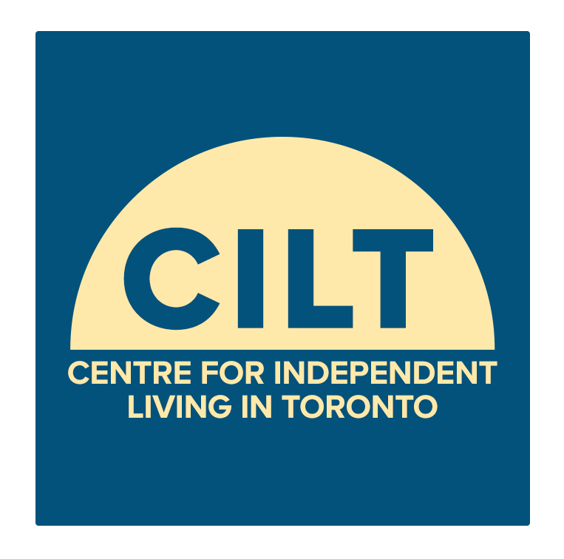
Presented by CILT, the City of Toronto, United Way Greater Toronto & Pooranlaw

