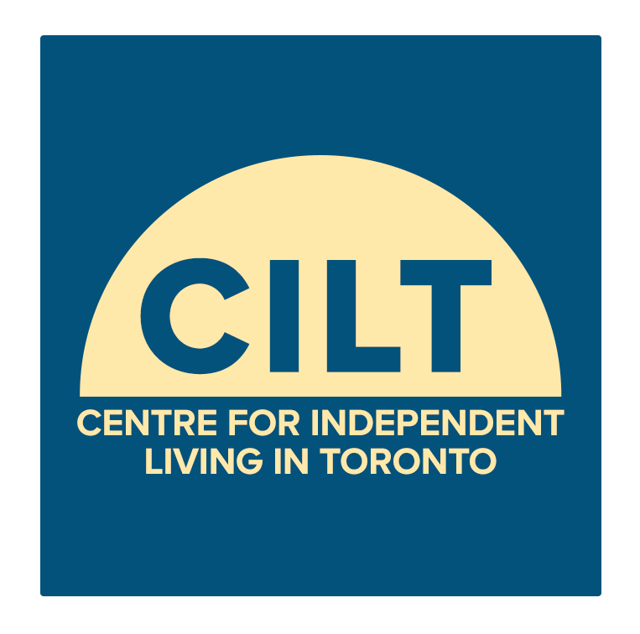
Would you like to work on a project that produces media stories on disability issues led by people with disabilities?

Or work with an advisory committee for such a project?

CILT’s D-NEXT Accessible Media Team is an accessible media lab that’s run by a creative team of writers, podcasters, short doc filmmakers and advisory members with disabilities.
Our D-NEXT Team starts a new project this Fall that will support up to 16 disabled storytellers to build on their skills in producing media stories in 2020. Participants will take a 6-week media training series and then work in teams producing stories through podcasts, mini-docs, videos, blogs and more. Trainings are in Winter and Spring 2020 (dates TBD).
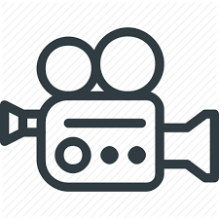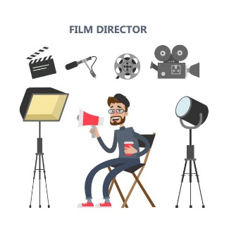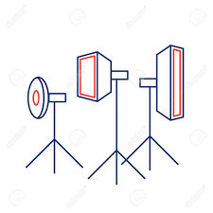

We are taking applications up to December 19th for our first round of trainings, starting at end of January 2020. Round 2 starts in April.

Adults with disabilities are invited to apply who have some experience in one or more of: journalism, writing, podcasting, shooting video, editing, blogging or related areas.

Honoraria, TTC reimbursement attendant services and some ASL interpretation services will be provided.

For info or to request a application, please contact: dnext@cilt.ca

